**How to Create a Purchase Order**

1. To begin the process, open POUPPR screen and click the plus sign
2. Click on the dialog box 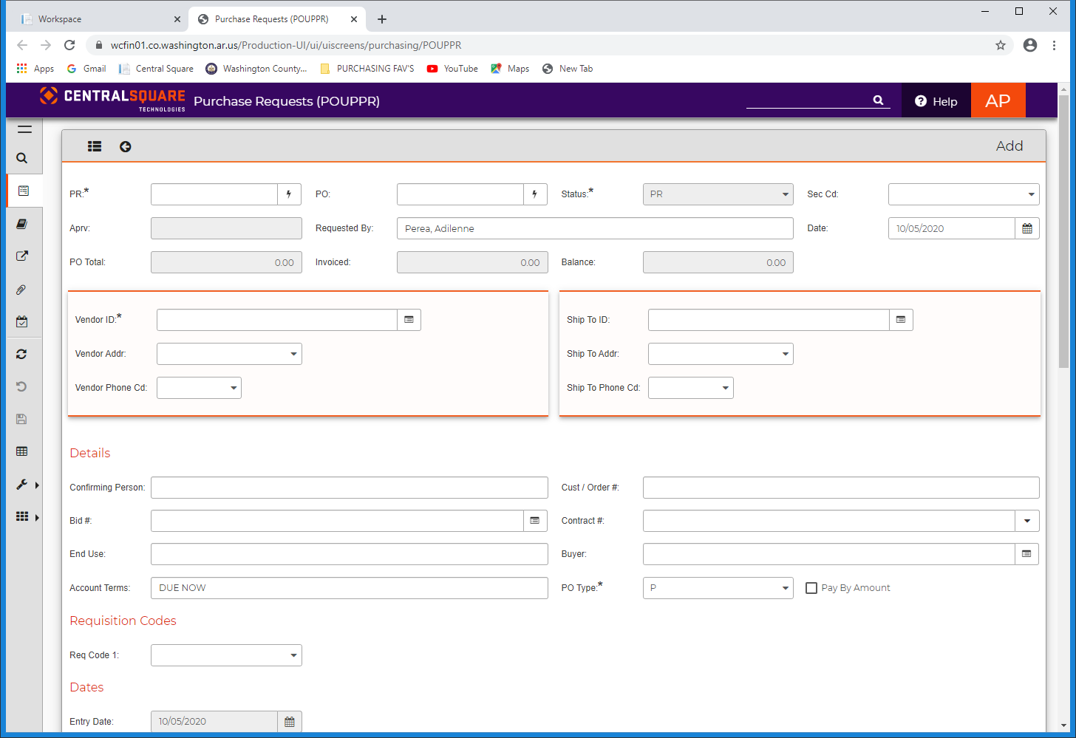 next to the purchase request number box (PR:) scroll down to Auto [PR.SEED]
3. Click the Security Code Drop down arrow and select the appropriate department

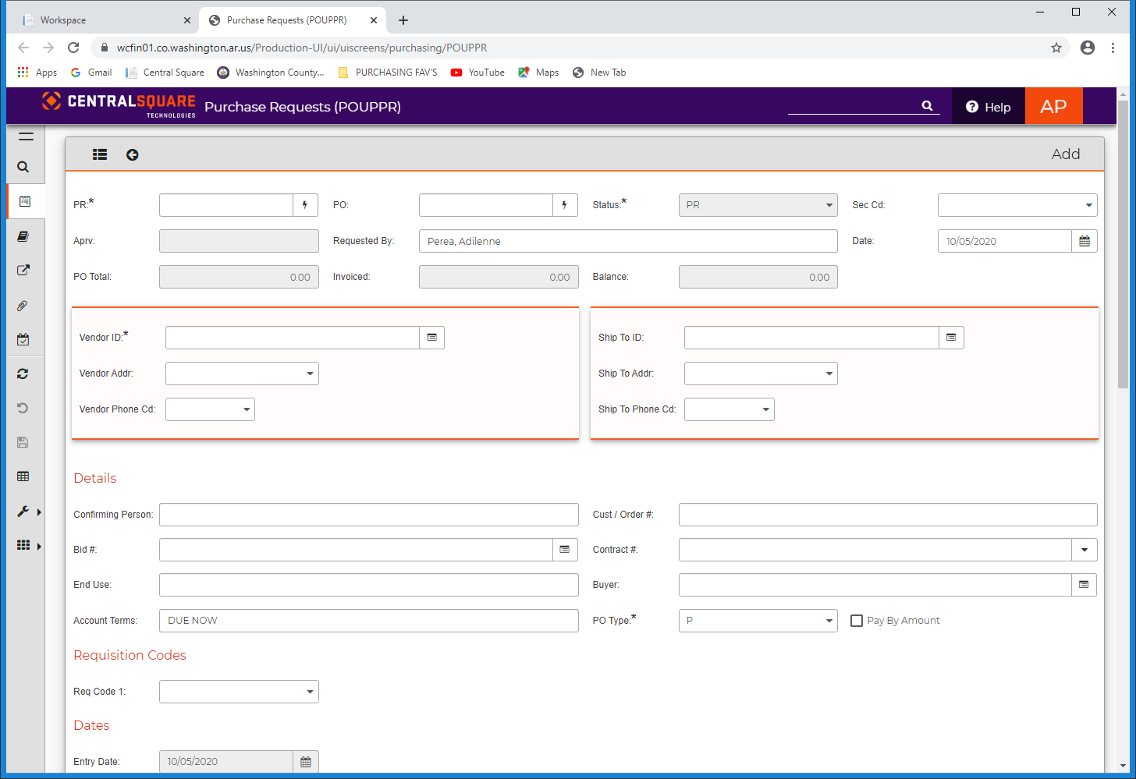

1. Click the dialog box 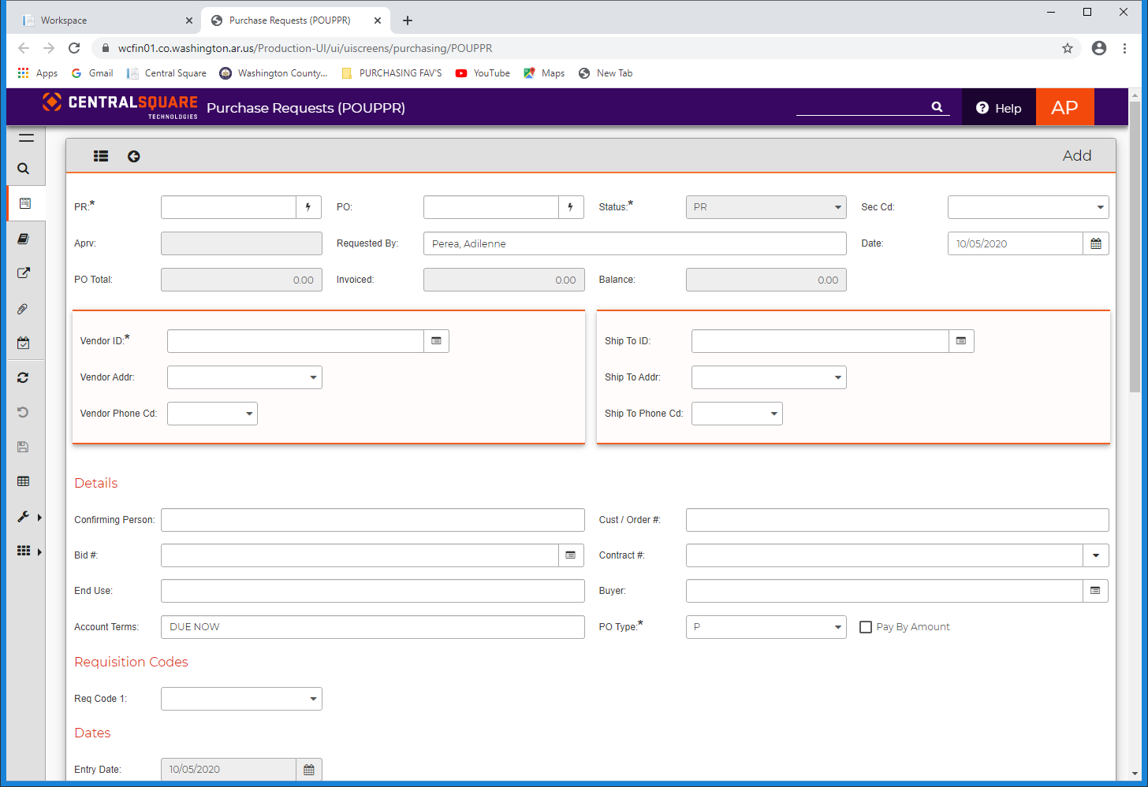 next to the Vendor ID
   1. To look for a vendor: put *in front and/or behind the search word in the highlighted box (ex: Office Depot - *Office De*, Office*, *Depot) and press enter
   2. Select the appropriate name on the list and click OK

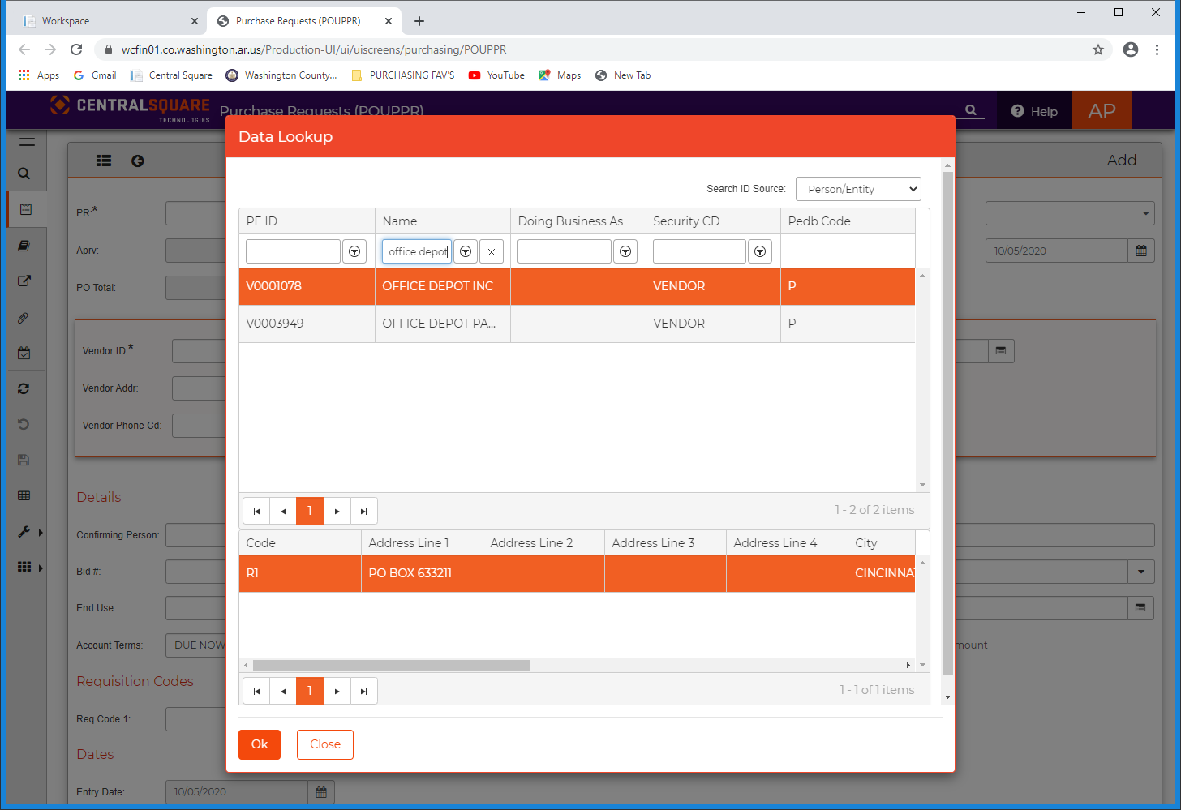

1. Click on the dialog box  next to the Ship To to look up your ship to location or use the list provided below

|  |  |  |  |
| --- | --- | --- | --- |
| S0001-COURTHOUSE | S0005-HISTORIC COURTHOUSE | S0009-SOUTH CAMPUS ANNEX | S0013-ANIMAL SHELTER |
| S0002-SHERIFF | S0006-JUDICIAL ANNEX | S0010-EMERG OPERATION CENTER | S0016-SPRINGDALE REVENUE |
| S0003-ROAD DEPT | S0007-HEALTH DEPT | S0011-CORONER | S0017- FAYETTEVILLE REVENUE |
| S0004-JUV JUSTICE COMPLEX | S0008-COUNTY LIBRARY | S0012-COOP ENTENSION SERVICE | S0018-LINCOLN REVENUE |
|  |  |  | S0019-VETERAN SERVICES |

1. Click in the box next to End Use: 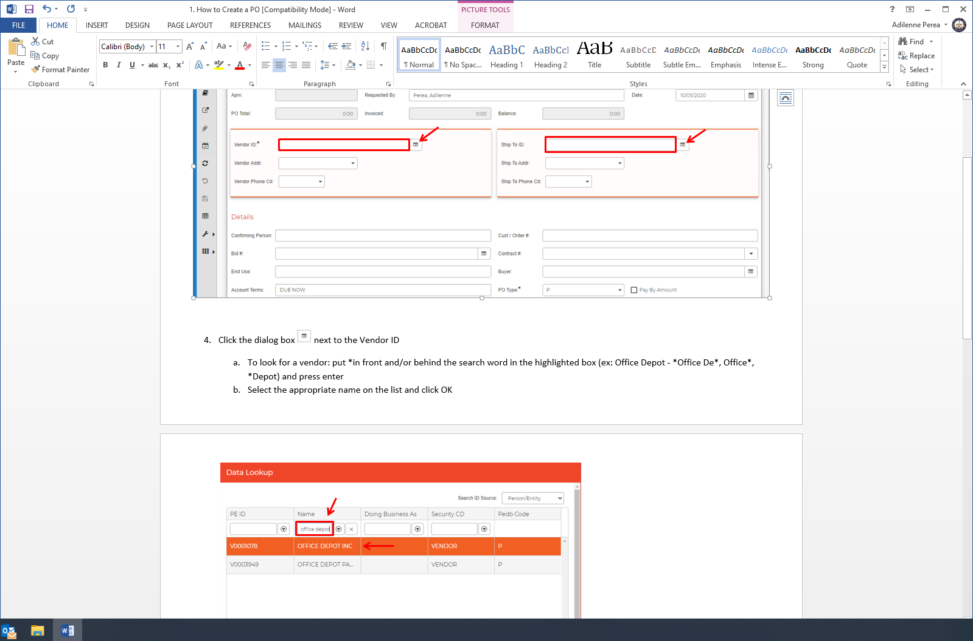 and add the requestor’s information.
2. You are ready to enter the purchasing information needed for the PO. Click in the Quantity box and place a 1. Press Tab to enter the Unit Price for the specific line item. Press Tab to move to the Item Description. Type in the description of the desired line item and press Tab again. Press Tab three times and enter the Fund and Department. Press tab to enter the line item. Tab over to the Amount and enter the total amount for the item. Press enter.
   1. If another line item is need for the PO, repeat the above process in the Item Number 0002 row. Continue the process until all line items are listed correctly on the PO.

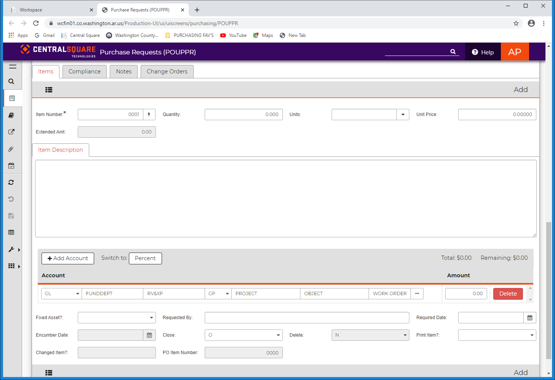

10000118

2001

Insert description here

1. You are ready to finalize the PO. Carefully review all of the information and proceede to the pending task tab 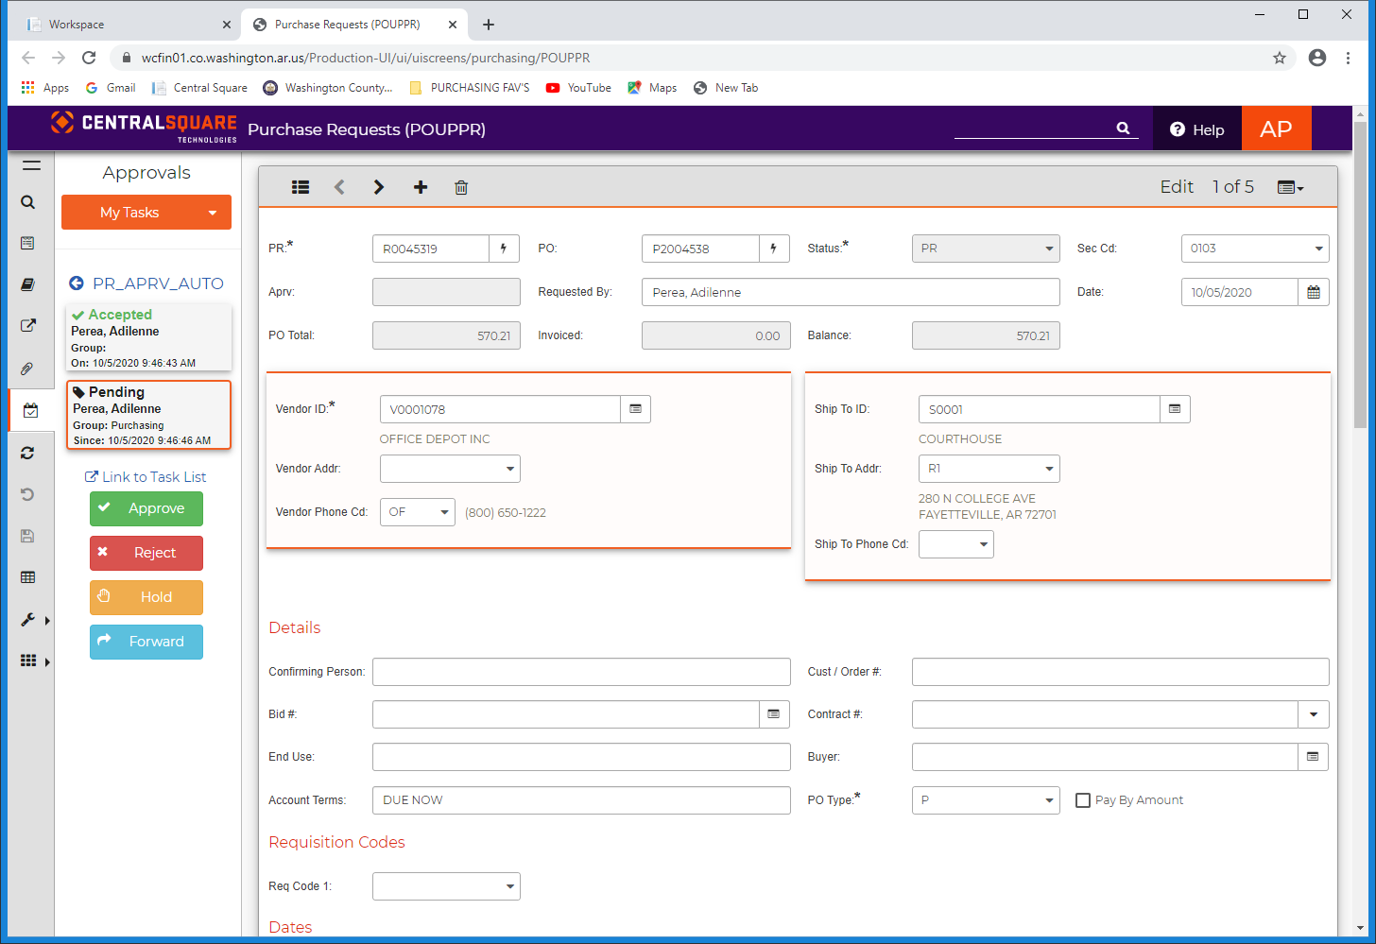, select My Task. Click on the green check mark to approve, Click submit and wait for final approval.

 