**Cardholder PCard Instructions**

1. To begin, open your PCard statement from the bank and P-Card Reconciliation (APPCEZ)

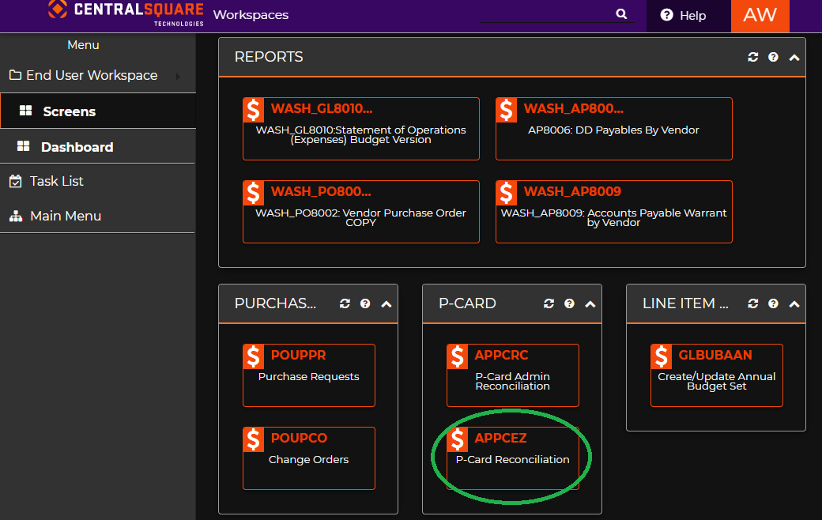

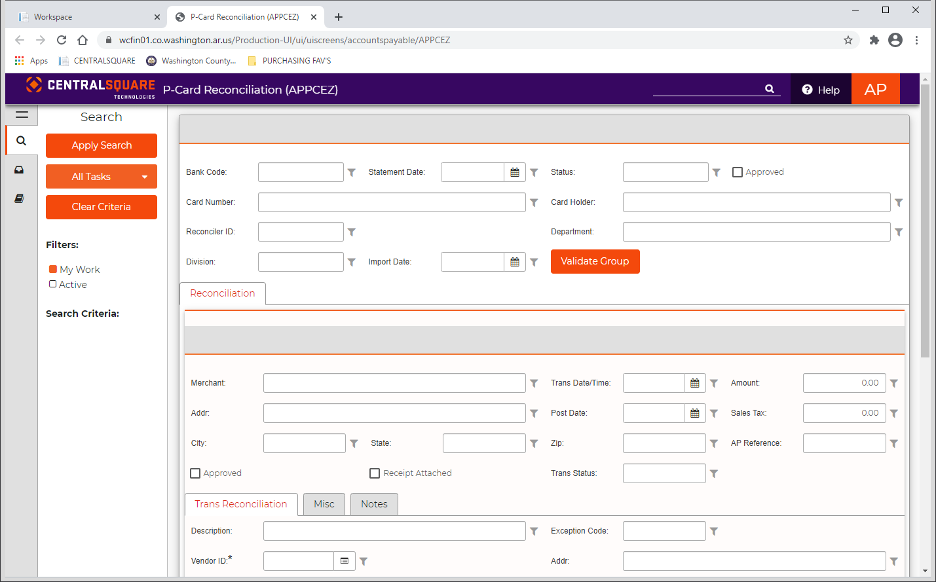

1. Click on the , your P-Card transactions should appear automatically.
   1. 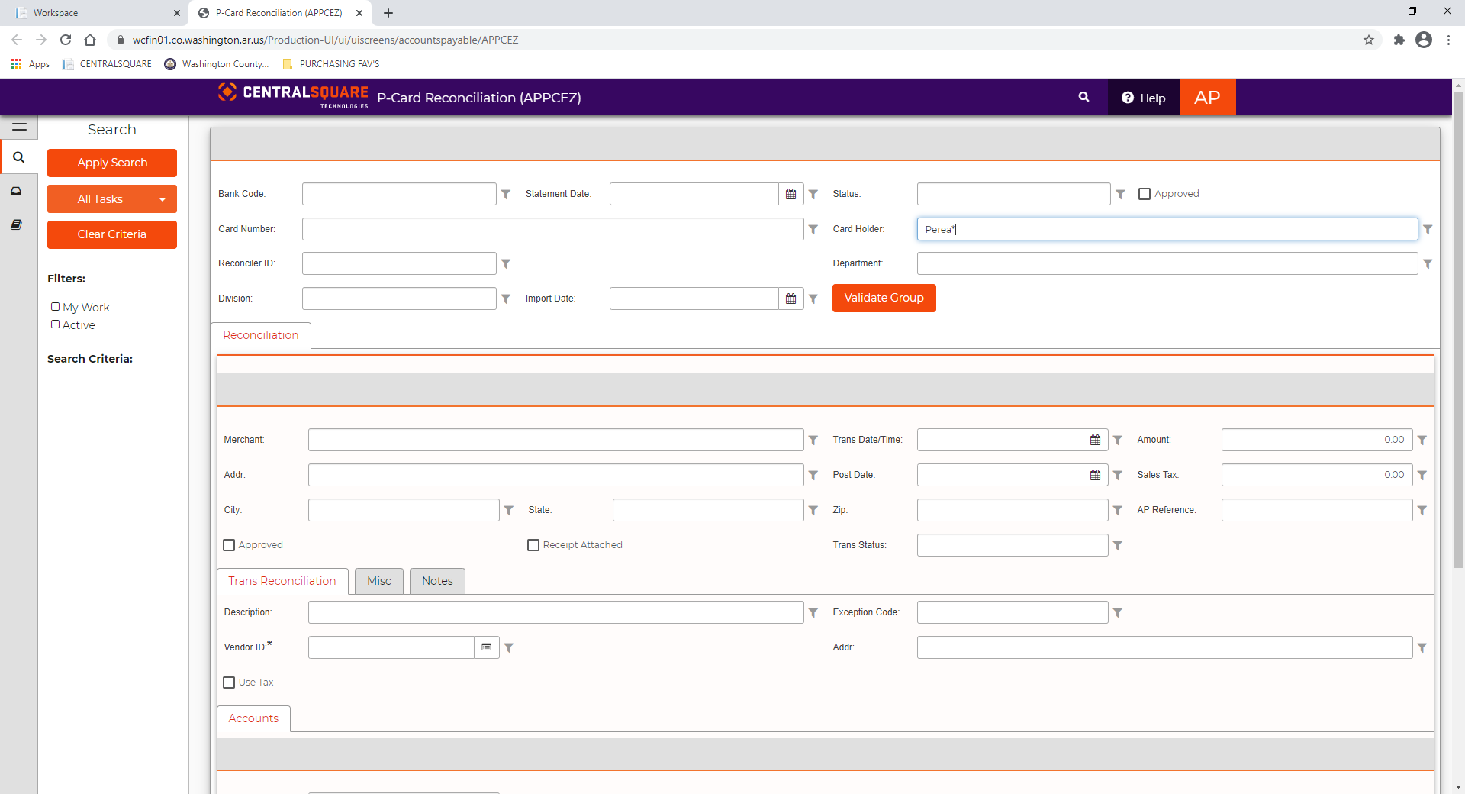If transactions do not appear automatically, search by last name followed by an asterisk and click ENTER. Ex.

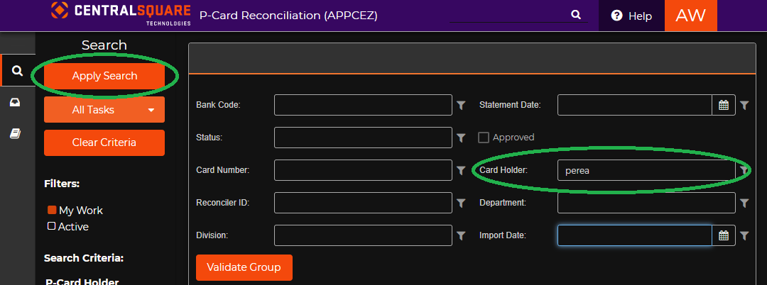

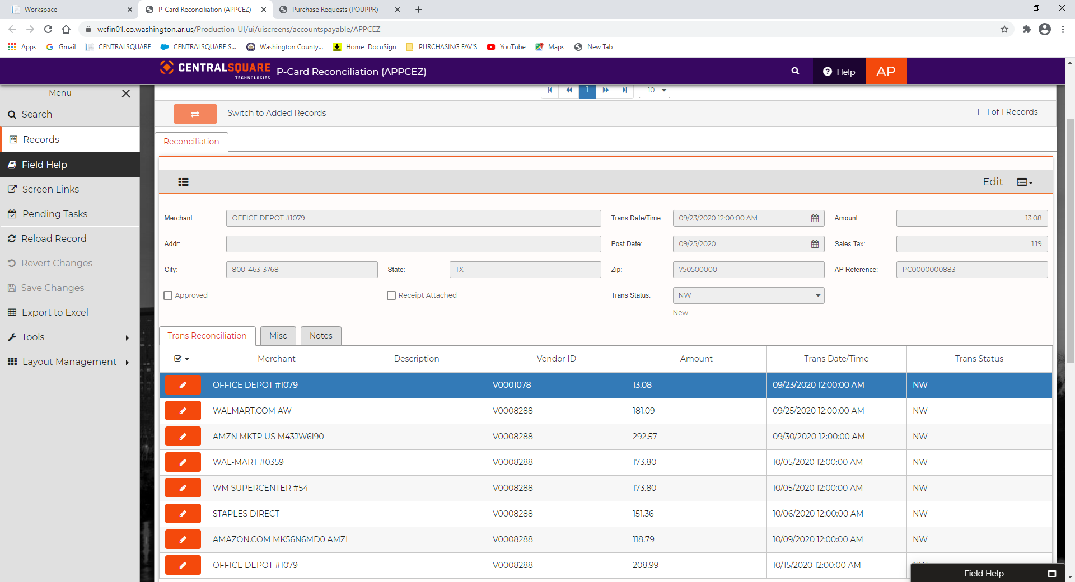

1. 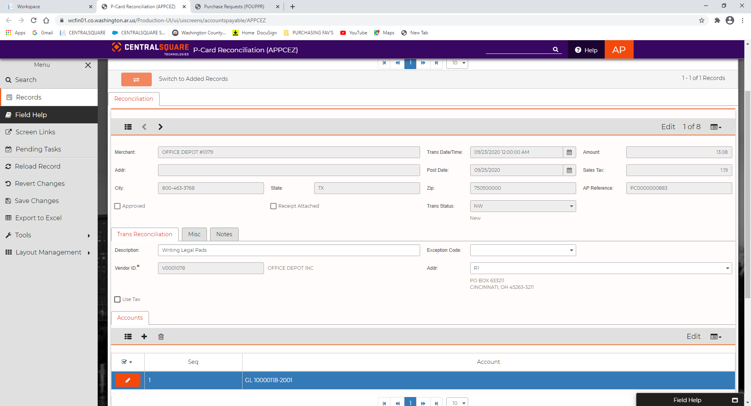Scroll down to the “Trans Reconciliation” Tab, select the and add the Description for the transaction
2. Scroll down to the “Accounts” Tab and select the and verify the Department Fund and Item Number for the purchase.

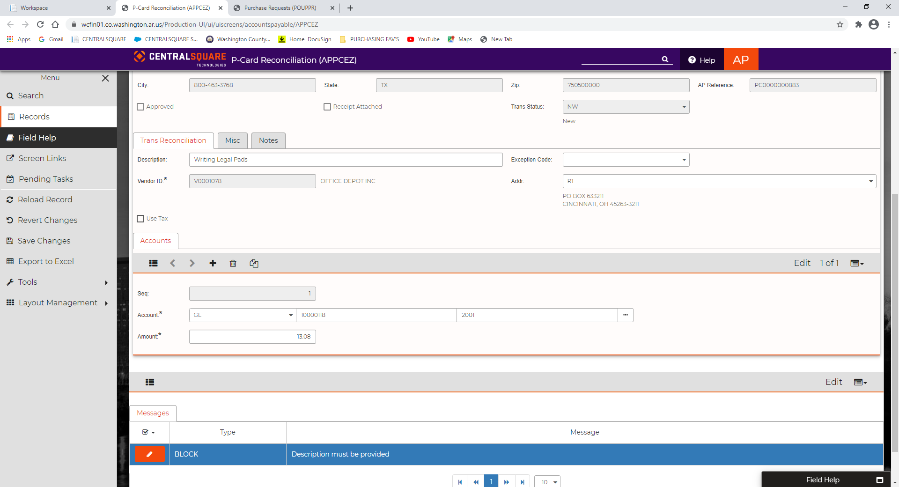

1. Press Enter and Record your entry.
2. Continue on to the next entry by selecting the Next Arrow, under the Reconciliation tab, complete Steps 3 – 5.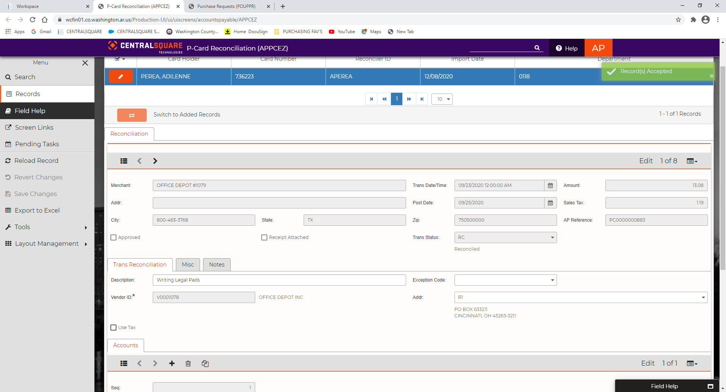
3. Verify all transaction are complete by switching to grid mode. Pending items will have a blank description.



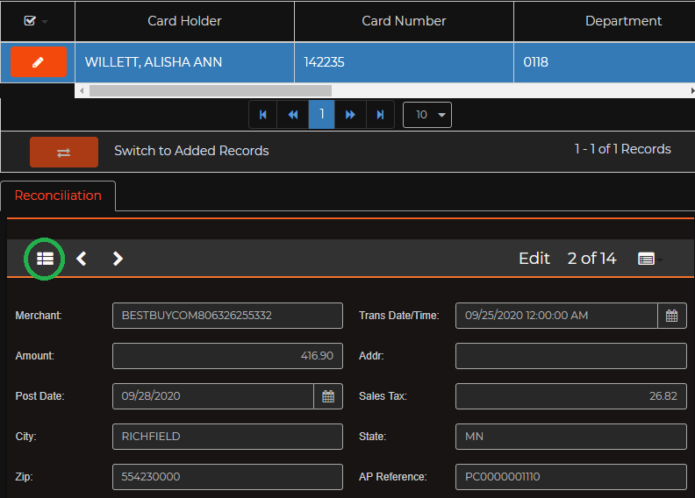

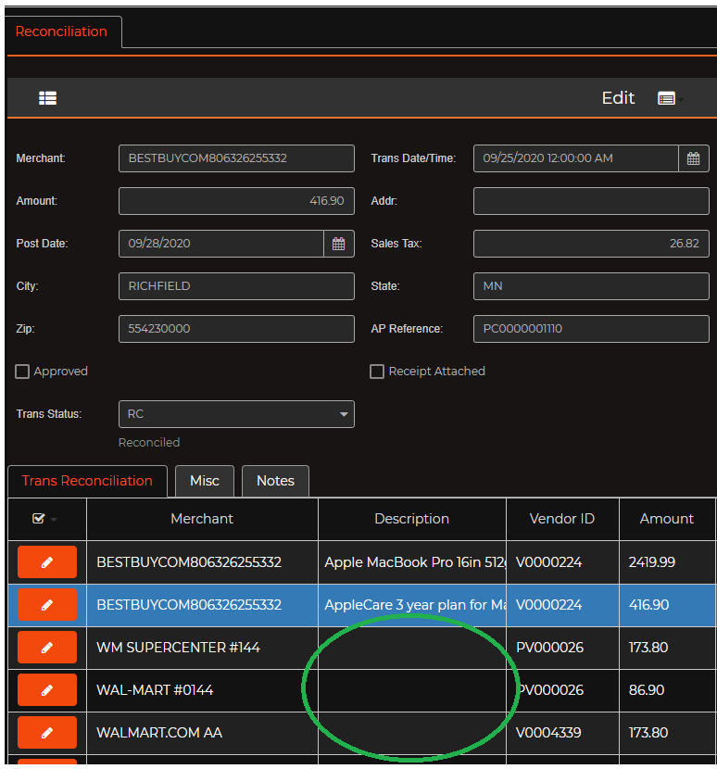

1. Continue Steps 3 – 5 until all are complete and no descriptions are blank. Click the edit pencil button for each transaction, update all descriptions, line items, and AP Invoice numbers
2. Once you have completed all transactions, scroll to the top of the page and select the next to the Card Holder Name.

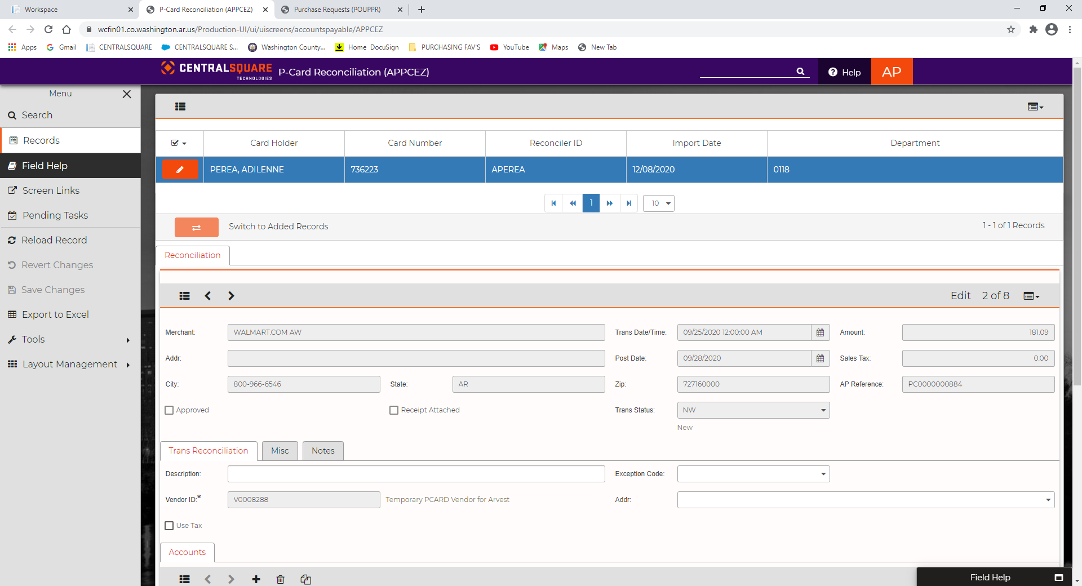

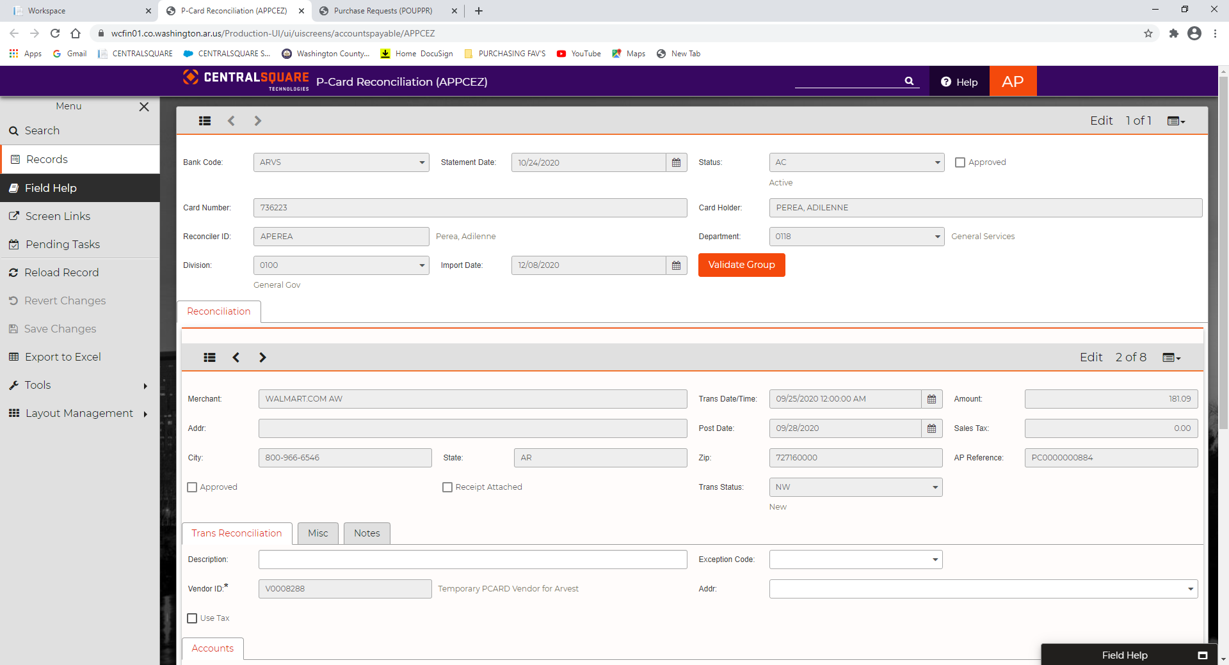

1. Select the
2. 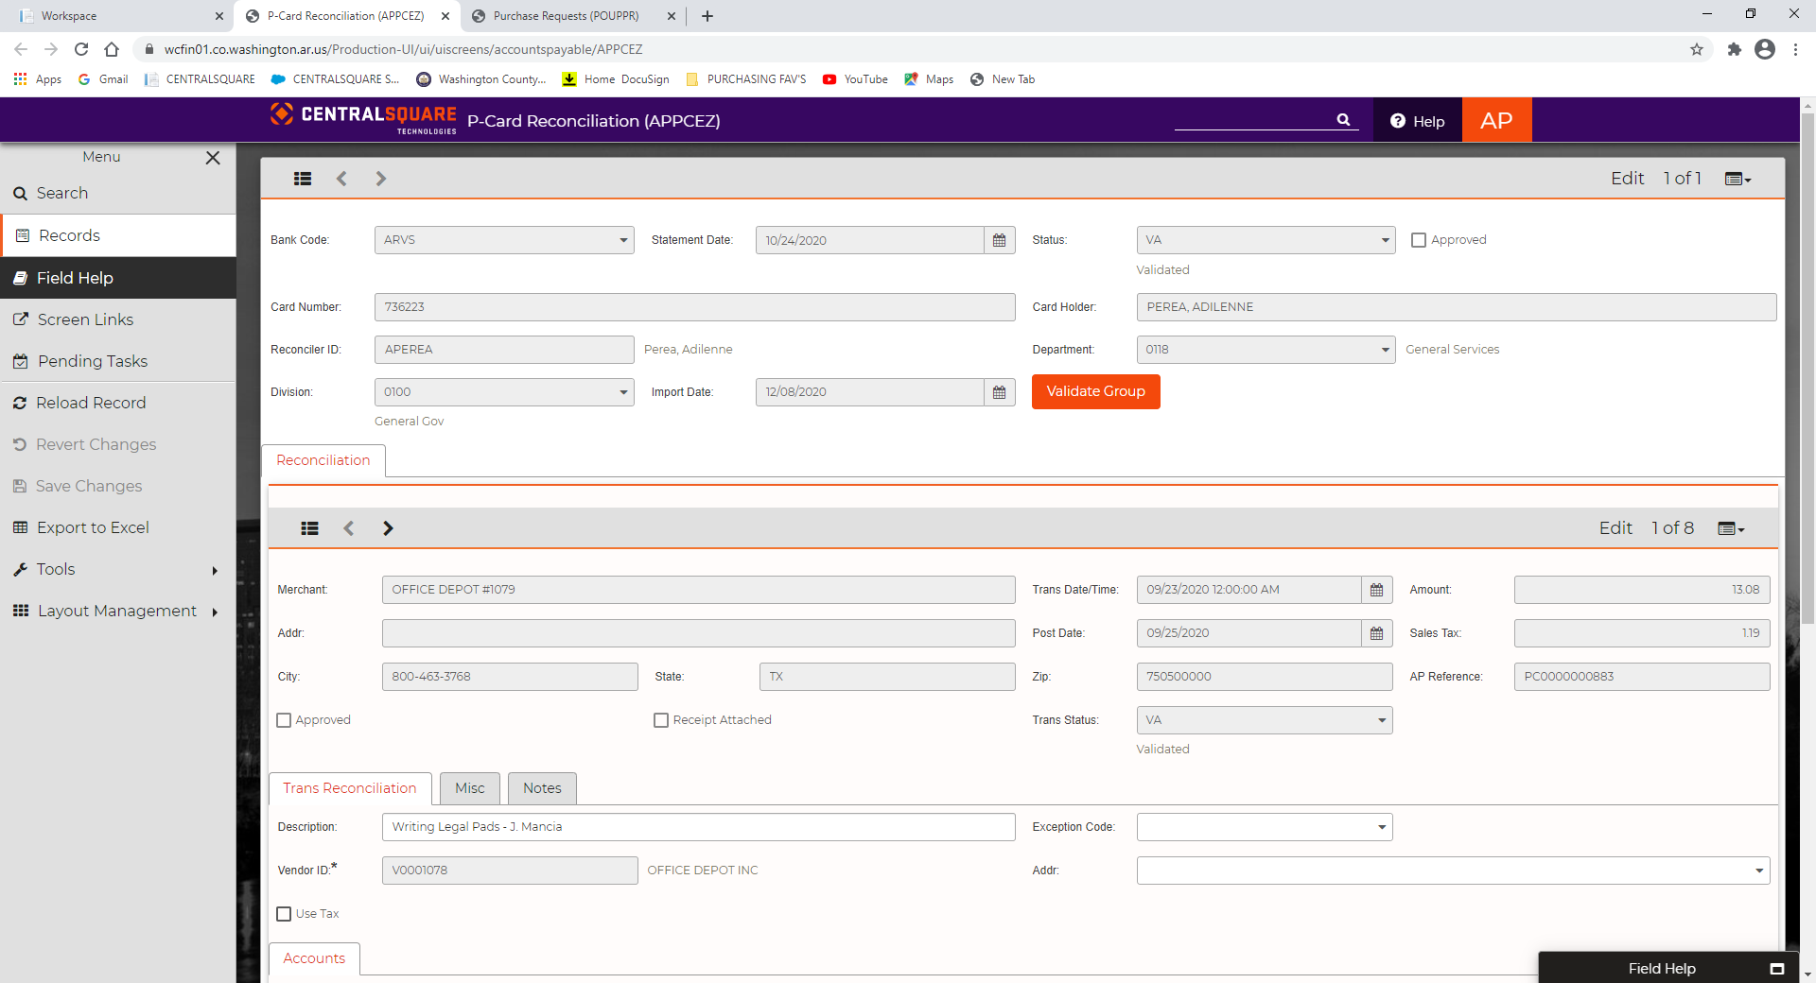Under the left hand side Menu, select the tab for the Task List.

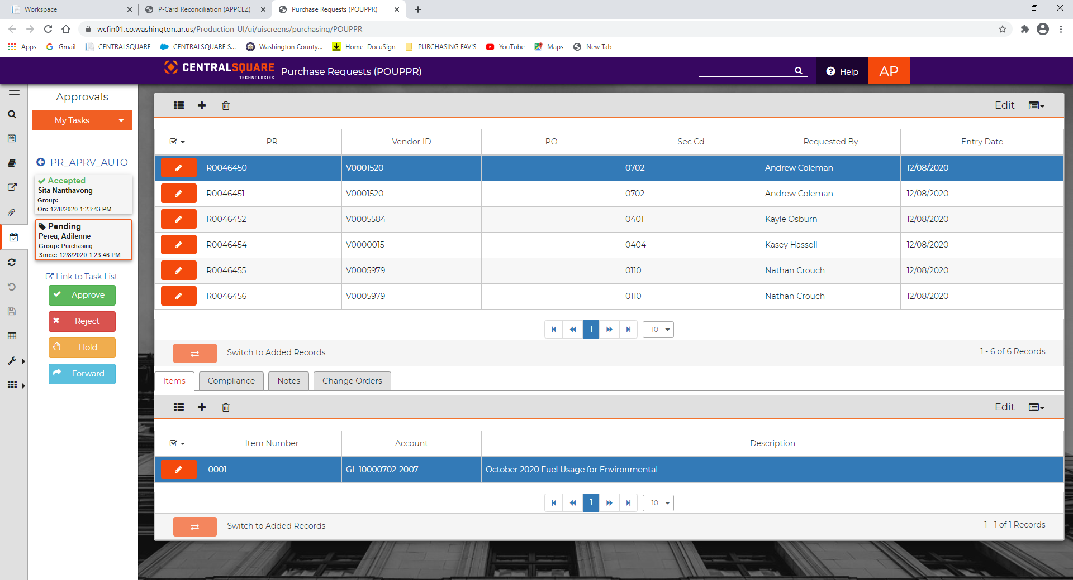

1. Click on each transaction and Select the button
2. The PCard Reconciliation should be “PENDING” for a Bill Approver in your department and that will complete the PCard Reconciliation.

**BILL APPROVERS**

1. To approve and end users PCard Reconciliation, Open P-Card Admin Reconciliation (APPCRC)

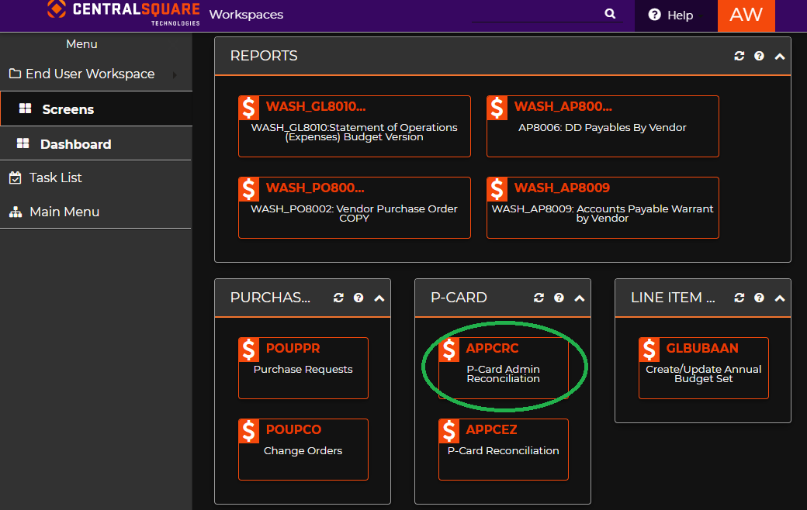



1. Click on the , to load all Statements

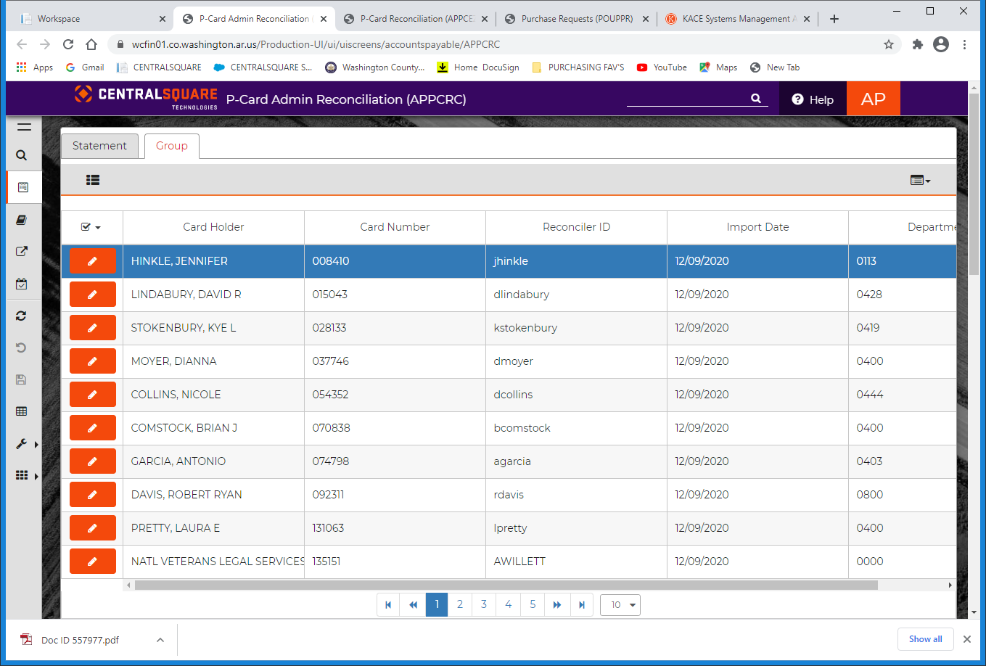

1. Select the

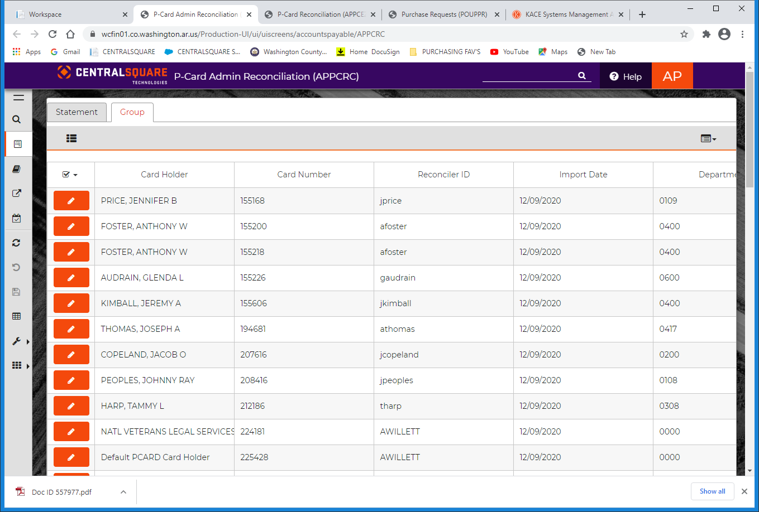

* 1. 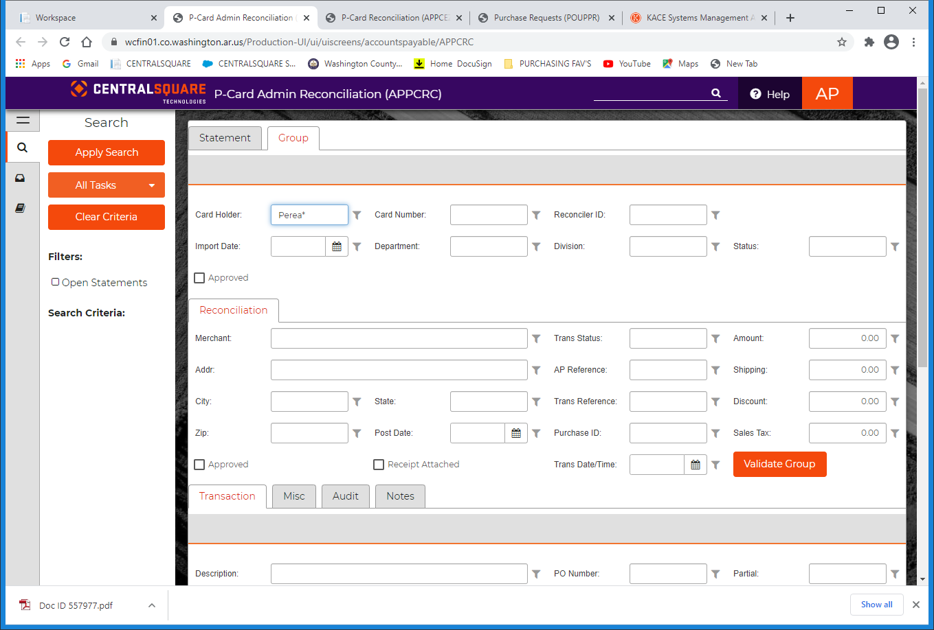Search for end user by selecting the and enter the Card Holders Last Name, and press Enter. Ex.

1. 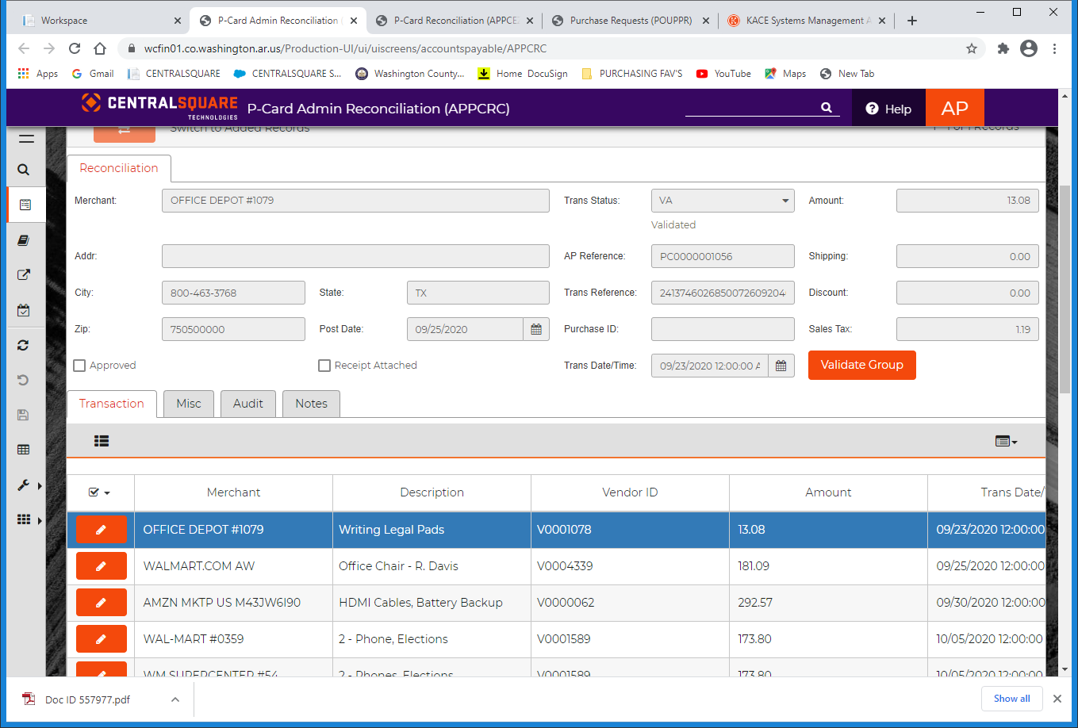Scroll down to the Tab, and review all entries.
2. Add the AP invoice number. This will be the same as the information previously placed in the top right box of the POUPPR screen. Use the last six digits of the invoice or transaction number. Ex. MM/DD/YY-123456

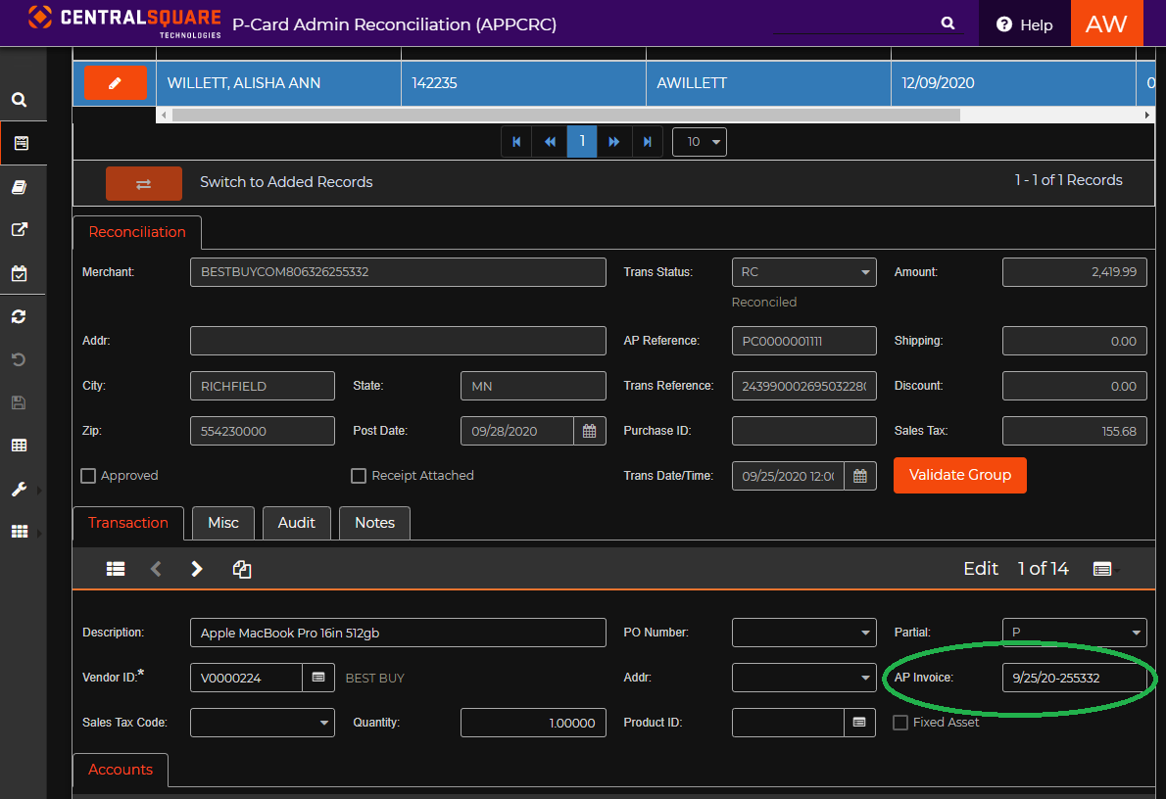

1. Scroll down to the “Accounts” Tab and select the or the number to verify the Department Fund and Item Number for the purchase. Make corrections by clicking the number and adjusting in the popup box. 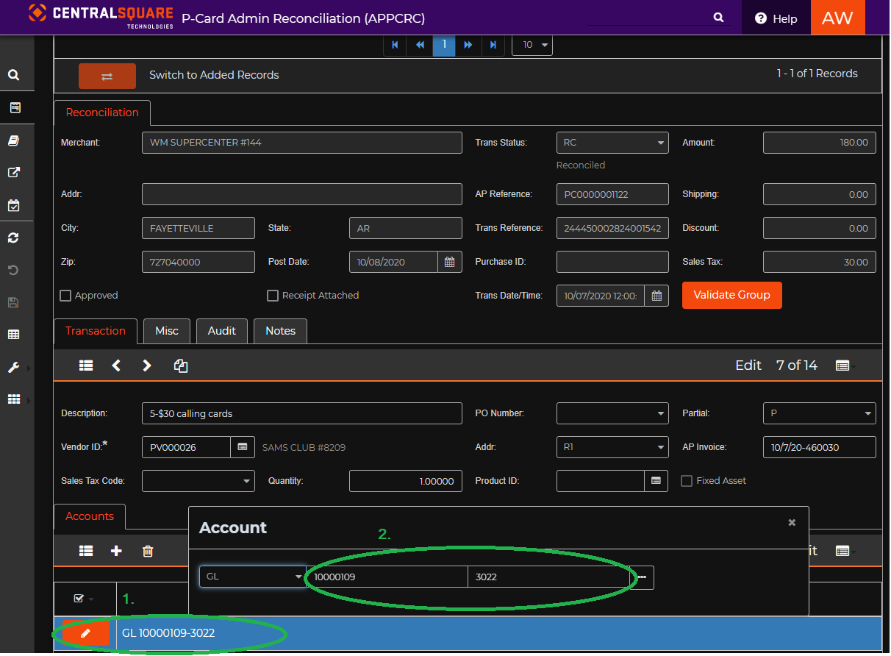

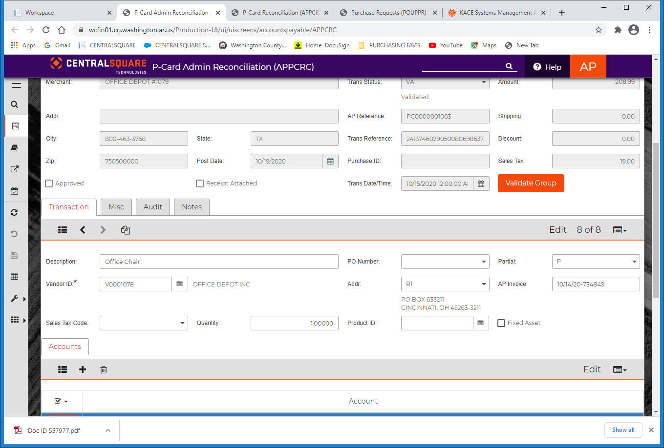

1. Select the to view all or < > the arrows to continue on to the next transaction.



1. Under the left hand side Menu, select the tab for the Task List.



1. Select the
2. The PCard Reconciliation should be “PENDING” for a Finance Group Bill Approver
3. Combine receipts with statement and send it up.